Bug / Defect LifCycle

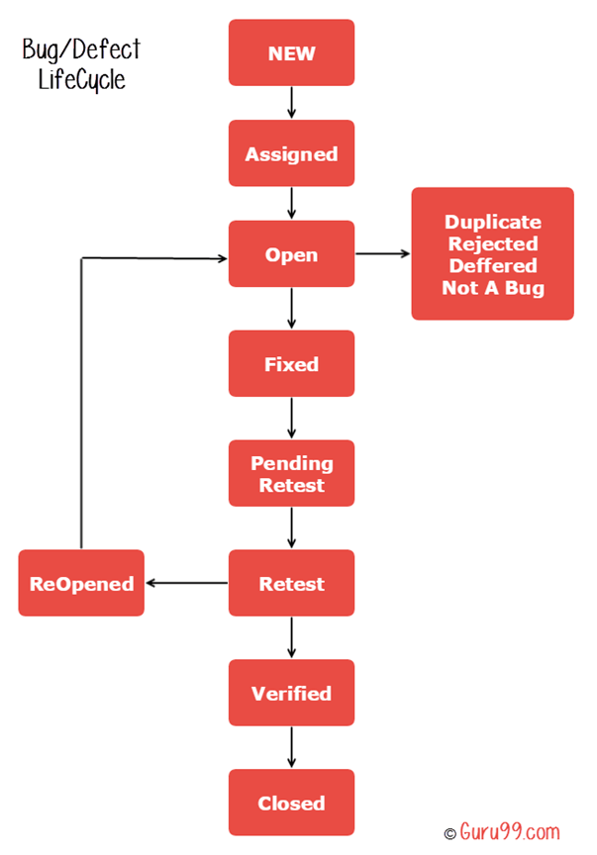

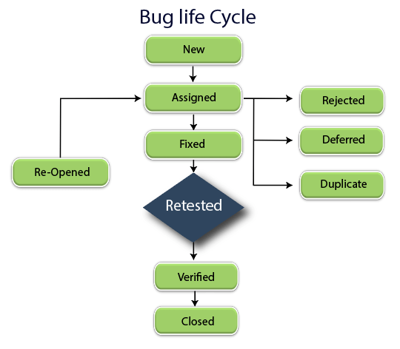

Priority:

* How fastly Bugs has been fixed
* Clent point of view
* Priority ( Highest or High , Medium , Low) (P1,P2,P3)\

Severity:

* How badly the bug affected the application or build
* Severity levels(block, critical , highest ,high, medium , low)

Defect Leakage:

* After project release to the client , if client identified any bug is called defect leakage

Homework

* High priority eg
* Low priority eg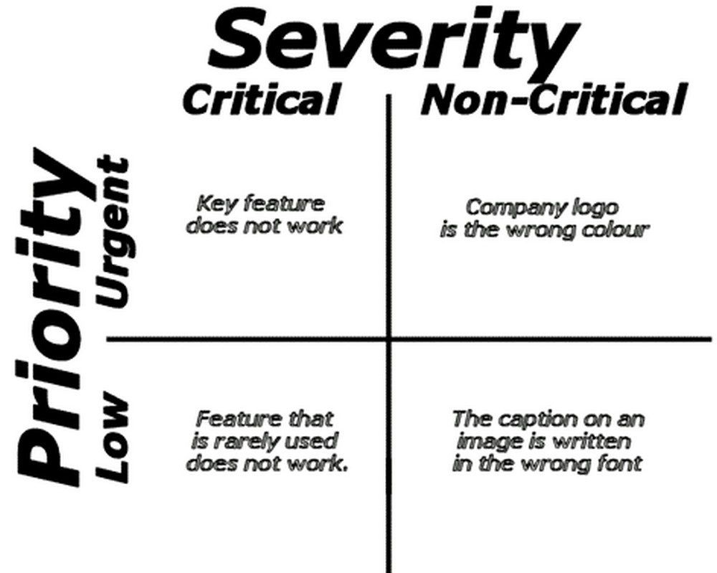

Types of Software Testing:

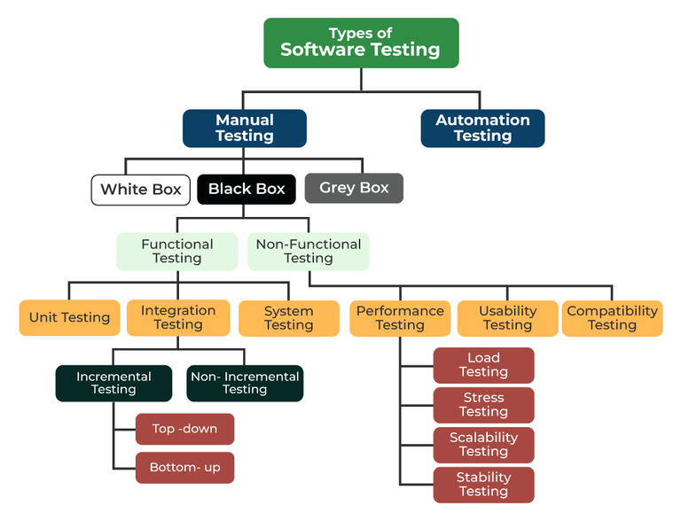

System testing – end to end testing

Testing Terminology:

1. Adhoc testing (Random testing)(no plan , no doc , but knows the flow)
2. Monkey testing(Testing with a person without any Application knowledge)
3. Smoke Testing(Initial testing , to check major function)(sys test)
4. Retesting(Same function to be tested repetitively)
5. Sanity Testing(2nd level of testing (testing the code with single page for bugs)
6. Regression Testing(New features added then testing the entire application for any bugs)
7. Exploratory Testing(exploring the application and understanding the functionalities and testing )
8. End to End testing (Overall functionality testing including the integration)

Bug Parameter

* S.no
* Page name
* Defect ID/Test caseID
* Web element Name
* Bug description
* Steps to Reproduce(important)
* Excepted result
* Actual Result
* Tested By
* Tested Date
* Severity
* Tested Browser
* Assigned Developers
* Defect Status
* Defect Closed Date
* Remark
* Evidence